
Joins
CREATE DATABASE J;
USE J;
CREATE TABLE Department (
dept_id INT PRIMARY KEY,
dept_name VARCHAR(30)
);
CREATE TABLE Student (
student_id INT PRIMARY KEY,
student_name VARCHAR(30),
dept_id INT
);
CREATE TABLE StudentMentor (
student_id INT PRIMARY KEY,
student_name VARCHAR(30),
mentor_id INT
);
INSERT INTO Department VALUES
(10, 'Computer Science'),
(20, 'Information Science'),
(30, 'Data Science'),
(40, 'Electronics');
INSERT INTO Student VALUES
(1, 'Manu', 10),
(2, 'Varun', 20),
(3, 'Vaibhav', 30),
(4, 'Raghavendra', NULL);
INSERT INTO StudentMentor VALUES
(1, 'Manu', NULL),
(2, 'Varun', 1),
(3, 'Vaibhav', 1),
(4, 'Raghavendra', 2);
1. Inner Join: Students enrolled in existing departments
SELECT s.student_id, s.student_name, d.dept_name
FROM Student s
INNER JOIN Department d ON s.dept_id = d.dept_id
;
Output :

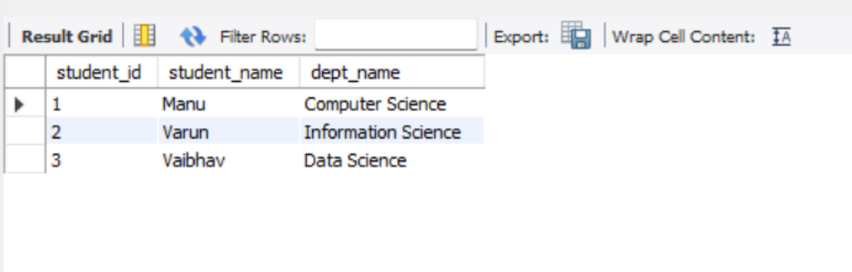
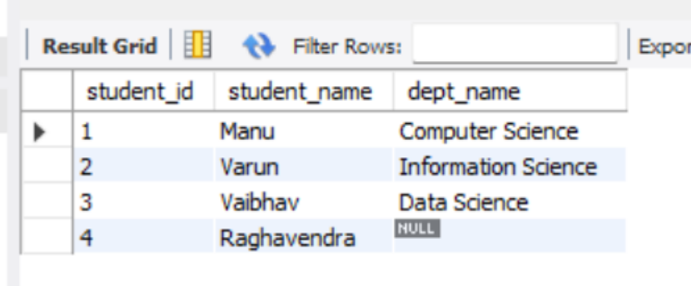
2. Left Join
SELECT s.student_id, s.student_name, d.dept_name
FROM Student s
LEFT JOIN Department d ON s.dept_id = d.dept_id;
3. Right Join
SELECT s.student_id, s.student_name, d.dept_name
FROM Student s
RIGHT JOIN Department d ON s.dept_id = d.dept_id;

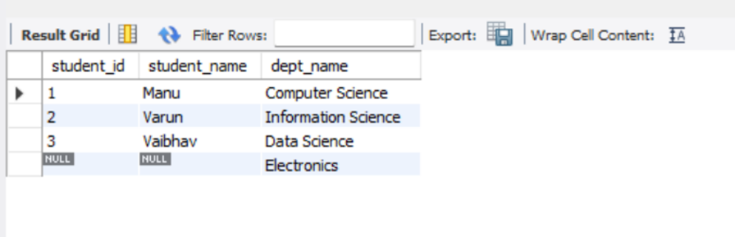
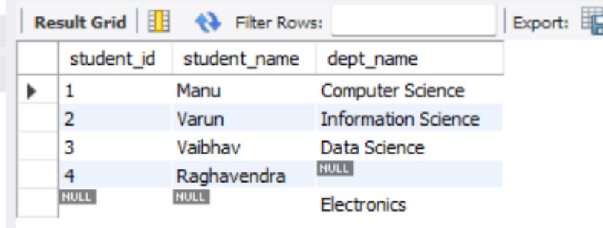
4. Fully Outer Join
SELECT s.student_id, s.student_name, d.dept_name
FROM Student s
LEFT JOIN Department d ON s.dept_id = d.dept_id
UNION SELECT s.student_id, s.student_name, d.dept_name
FROM Student s
RIGHT JOIN Department d ON s.dept_id = d.dept_id;
5. Cross Join
SELECT s.student_name, d.dept_name
FROM Student s
CROSS JOIN Department d;

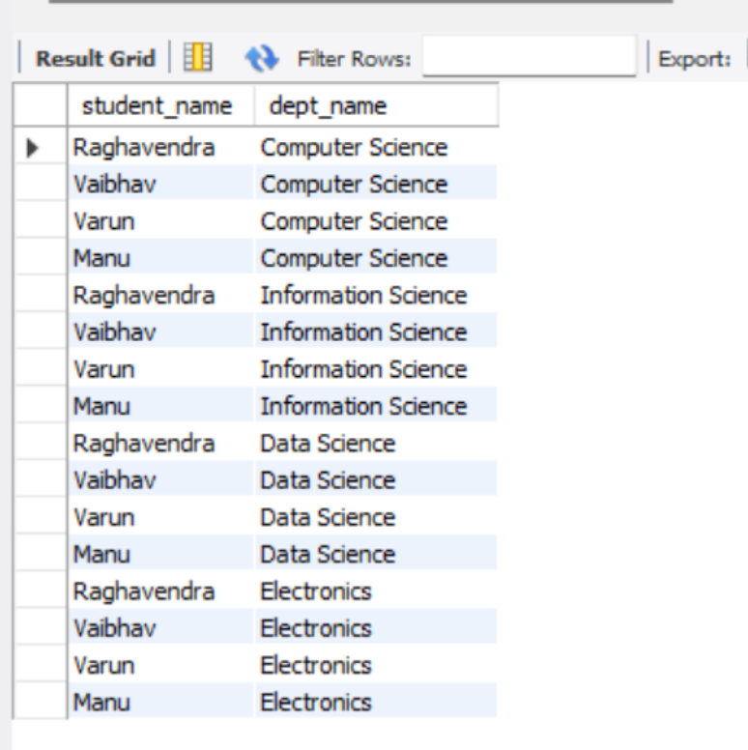
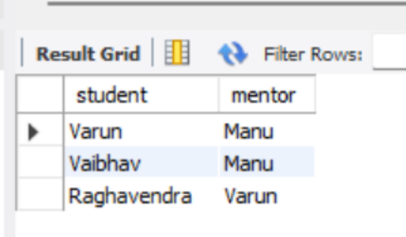
6. Self Join
SELECT s.student_name AS student, m.student_name AS mentor
FROM StudentMentor s
INNER JOIN StudentMentor m ON s.mentor_id = m.student_id;

LAB 8
Group by having order by clause
Group By
CREATE DATABASE P;
USE P;
CREATE TABLE Student (
student_id INT PRIMARY KEY,
student_name VARCHAR(30),
dept VARCHAR(30),
marks INT
);
INSERT INTO Student VALUES
(1, 'Manu', 'CS', 85),
(2, 'Vaibhav', 'IS', 72),
(3, 'Varun', 'DS', 90),
(4, 'Ragha', 'DS', 78),
(5, 'Priya', 'CS', 88),
(6, 'Kiran', 'IS', 65),
(7, 'Sneha', 'DS', 95);
SELECT student_name, dept, marks
FROM Student
ORDER BY marks DESC;
Output :

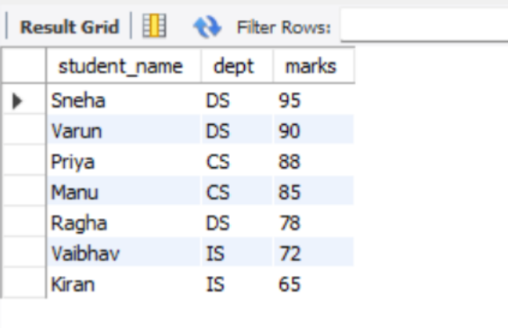
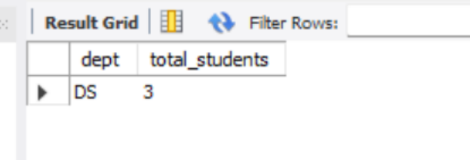
Having By :
SELECT dept, COUNT(*) AS total_students
FROM Student
GROUP BY dept
HAVING COUNT(*) > 2;
Order By :
SELECT dept,
COUNT(*) AS total_students,
SUM(marks) AS total_marks,
AVG(marks) AS avg_marks
FROM Student
GROUP BY dept;

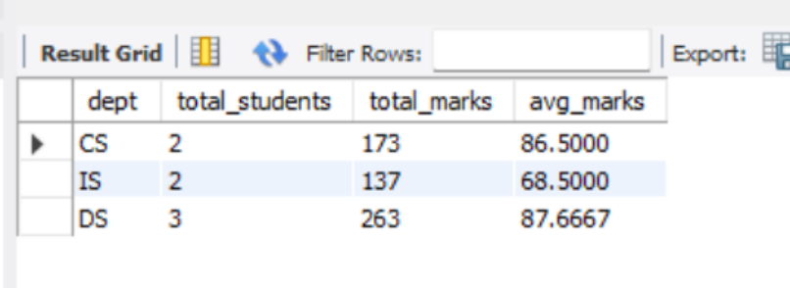
LAB 9
Procedure
Basic Procedure :
CREATE DATABASE S;
USE S;
CREATE TABLE Student (
student_id INT PRIMARY KEY,
student_name VARCHAR(30),
dept VARCHAR(30),
marks INT
);
INSERT INTO Student VALUES
(1, 'Manu', 'CS', 85),
(2, 'Vaibhav', 'IS', 72),
(3, 'Varun', 'DS', 90),
(4, 'Ragha', 'DS', 78),
(5, 'Priya', 'CS', 88),
(6, 'Kiran', 'IS', 65),
(7, 'Sneha', 'DS', 95);
DROP PROCEDURE IF EXISTS show_students;
DELIMITER $$
CREATE PROCEDURE show_students()
BEGIN
SELECT * FROM Student;

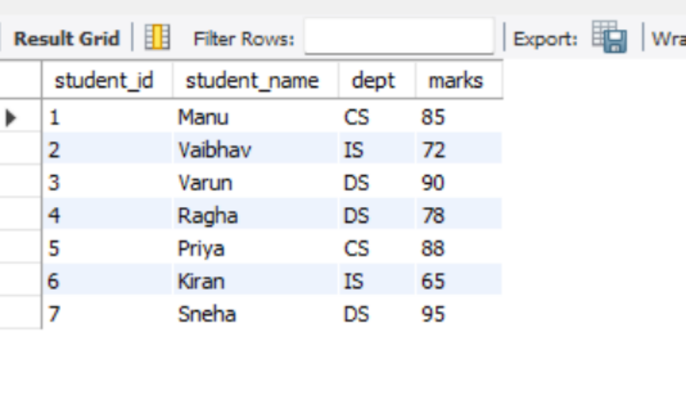
END$$
DELIMITER ;
CALL show_students();
Output :
Procedure with in parameter :
DELIMITER $$
CREATE PROCEDURE insert_student(
IN p_id INT,
IN p_name VARCHAR(30),
IN p_dept VARCHAR(30),
IN p_marks INT
)
BEGIN
INSERT INTO Student VALUES (p_id, p_name, p_dept, p_marks);
END$$
DELIMITER ;
CALL insert_student(8, 'Arun', 'IS', 80);
SELECT * FROM Student;

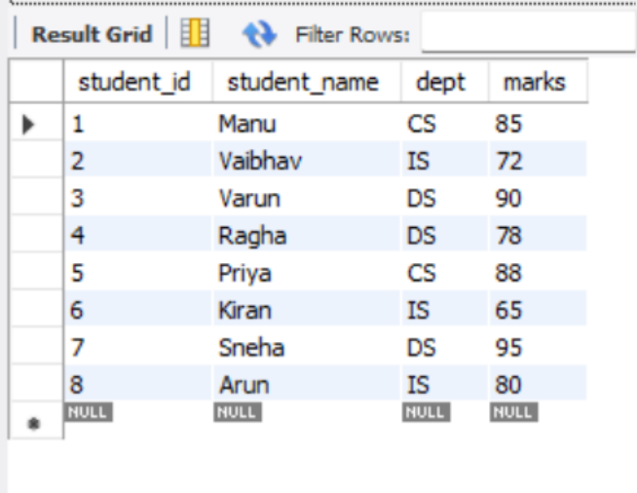
Procedure for update :
DELIMITER $$
CREATE PROCEDURE update_marks(
IN p_id INT,
IN p_new_marks INT
)
BEGIN
UPDATE Student
SET marks = p_new_marks
WHERE student_id = p_id;
END$$
DELIMITER ;
CALL update_marks(2, 79);
SELECT * FROM Student;

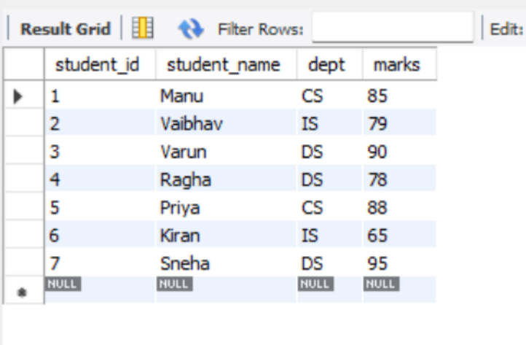
Procedure for delete :
DELIMITER $$
CREATE PROCEDURE insert_student(
IN p_id INT,
IN p_name VARCHAR(30),
IN p_dept VARCHAR(30),
IN p_marks INT
)
DELIMITER $$
CREATE PROCEDURE delete_student(
IN p_id INT
)
BEGIN
DELETE FROM Student
WHERE student_id = p_id;
END$$
DELIMITER ;
CALL delete_student(5);
SELECT * FROM Student;

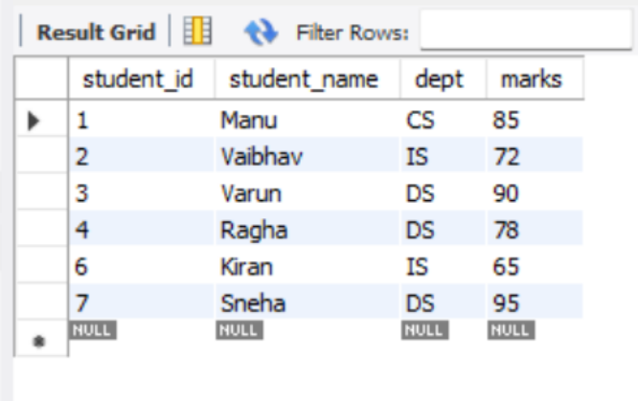
10. Triggers
-- Table Setup
CREATE TABLE Student (
student_id INT PRIMARY KEY,
student_name VARCHAR(30),
dept VARCHAR(30),
marks INT
);
CREATE TABLE Student_log (
log_id INT AUTO_INCREMENT PRIMARY KEY,
action VARCHAR(30),
student_id INT,
log_time TIMESTAMP DEFAULT CURRENT_TIMESTAMP
);
INSERT INTO Student VALUES
(1, 'Asha', 'CS', 85),
(2, 'Ravi', 'IS', 72),
(3, 'Meena', 'DS', 90),
(4, 'John', 'DS', 78),
(5, 'Priya', 'CS', 88),
(6, 'Kiran', 'IS', 65),
(7, 'Sneha', 'DS', 95);

-- Drop triggers if they exist
DROP TRIGGER IF EXISTS before_student_insert;
DROP TRIGGER IF EXISTS after_student_insert;
DROP TRIGGER IF EXISTS before_student_update;
DROP TRIGGER IF EXISTS after_student_update;
DROP TRIGGER IF EXISTS before_student_delete;
DROP TRIGGER IF EXISTS after_student_delete;
DELIMITER $$
-- 1. BEFORE INSERT: Validate marks (marks cannot be negative or over 100)
CREATE TRIGGER before_student_insert
BEFORE INSERT ON Student
FOR EACH ROW
BEGIN
IF NEW.marks < 0 OR NEW.marks > 100 THEN
SIGNAL SQLSTATE '45000'
SET MESSAGE_TEXT = 'Marks must be between 0 and 100';
END IF;
END$$
-- 2. AFTER INSERT: Log insert operation
CREATE TRIGGER after_student_insert
AFTER INSERT ON Student
FOR EACH ROW
BEGIN
INSERT INTO Student_log (action, student_id) VALUES ('INSERT', NEW.student_id);
END$$
-- 3. BEFORE UPDATE: Prevent reduction of marks
CREATE TRIGGER before_student_update
BEFORE UPDATE ON Student
FOR EACH ROW
BEGIN
IF NEW.marks < OLD.marks THEN
SIGNAL SQLSTATE '45000'
SET MESSAGE_TEXT = 'Marks cannot be reduced';
END IF;
END$$
-- 4. AFTER UPDATE: Log update operation
CREATE TRIGGER after_student_update
AFTER UPDATE ON Student
FOR EACH ROW

BEGIN
INSERT INTO Student_log (action, student_id) VALUES ('UPDATE', NEW.student_id);
END$$
-- 5. BEFORE DELETE: Prevent deleting a distinction student (marks > 90)
CREATE TRIGGER before_student_delete
BEFORE DELETE ON Student
FOR EACH ROW
BEGIN
IF OLD.marks > 90 THEN
SIGNAL SQLSTATE '45000'
SET MESSAGE_TEXT = 'Cannot delete student with marks above 90';
END IF;
END$$
-- 6. AFTER DELETE: Log delete operation
CREATE TRIGGER after_student_delete
AFTER DELETE ON Student
FOR EACH ROW
BEGIN
INSERT INTO Student_log (action, student_id) VALUES ('DELETE', OLD.student_id);
END$$
DELIMITER ;
-- Verification / Test Queries
INSERT INTO Student VALUES (8, 'Arun', 'IS', 80);
INSERT INTO Student VALUES (9, 'Divya', 'DS', 89);
UPDATE Student SET marks = 75 WHERE student_id = 2;
UPDATE Student SET marks = 92 WHERE student_id = 1;
DELETE FROM Student WHERE student_id = 6;
DELETE FROM Student WHERE student_id = 5;
SELECT * FROM Student;
SELECT * FROM Student_log;
Output :



